**FRONT-END: NET BEANS IDE**

package ex09;

import javax.swing.*;

import java.sql.*;

import java.sql.Statement.*;

public class employee extends javax.swing.JFrame {

Connection con;

Statement st;

PreparedStatement stmt;

ResultSet rs;

CallableStatement cstmt;

int i;

public employee() {

initComponents();

try{

Class.forName("oracle.jdbc.driver.OracleDriver");

JOptionPane.showMessageDialog(this,"Driver Loaded...");

try{

con = DriverManager.getConnection("jdbc:oracle:thin:@localhost:1521:orcl","system","vaishali");

JOptionPane.showMessageDialog(this,"Connected to Oracle Database...");

}

catch(SQLException ex)

{

JOptionPane.showMessageDialog(this,ex.getMessage());

}

}

catch(ClassNotFoundException ex)

{

JOptionPane.showMessageDialog(this,ex.getMessage());

}

}

@SuppressWarnings("unchecked")

// <editor-fold defaultstate="collapsed" desc="Generated Code">

private void initComponents() {

jPanel2 = new javax.swing.JPanel();

jLabel22 = new javax.swing.JLabel();

jPanel1 = new javax.swing.JPanel();

jLabel1 = new javax.swing.JLabel();

jLabel2 = new javax.swing.JLabel();

jLabel3 = new javax.swing.JLabel();

jLabel4 = new javax.swing.JLabel();

jLabel5 = new javax.swing.JLabel();

jLabel6 = new javax.swing.JLabel();

jTextField1 = new javax.swing.JTextField();

jTextField2 = new javax.swing.JTextField();

jTextField3 = new javax.swing.JTextField();

jTextField4 = new javax.swing.JTextField();

jTextField5 = new javax.swing.JTextField();

jTextField6 = new javax.swing.JTextField();

Insert = new javax.swing.JButton();

Update = new javax.swing.JButton();

Delete = new javax.swing.JButton();

jLabel7 = new javax.swing.JLabel();

jLabel8 = new javax.swing.JLabel();

jLabel9 = new javax.swing.JLabel();

jLabel10 = new javax.swing.JLabel();

jLabel11 = new javax.swing.JLabel();

jLabel12 = new javax.swing.JLabel();

jLabel13 = new javax.swing.JLabel();

jLabel20 = new javax.swing.JLabel();

jLabel14 = new javax.swing.JLabel();

jLabel15 = new javax.swing.JLabel();

jLabel16 = new javax.swing.JLabel();

jLabel18 = new javax.swing.JLabel();

jLabel19 = new javax.swing.JLabel();

jLabel21 = new javax.swing.JLabel();

jLabel17 = new javax.swing.JLabel();

Search_PayRoll = new javax.swing.JButton();

Exit = new javax.swing.JButton();

Reset = new javax.swing.JButton();

javax.swing.GroupLayout jPanel2Layout = new javax.swing.GroupLayout(jPanel2);

jPanel2.setLayout(jPanel2Layout);

jPanel2Layout.setHorizontalGroup(

jPanel2Layout.createParallelGroup(javax.swing.GroupLayout.Alignment.LEADING)

.addGap(0, 100, Short.MAX_VALUE)

);

jPanel2Layout.setVerticalGroup(

jPanel2Layout.createParallelGroup(javax.swing.GroupLayout.Alignment.LEADING)

.addGap(0, 100, Short.MAX_VALUE)

);

jLabel22.setText("jLabel22");

setDefaultCloseOperation(javax.swing.WindowConstants.EXIT_ON_CLOSE);

jLabel1.setText("EID");

jLabel2.setText("ENAME");

jLabel3.setText("DOB");

jLabel4.setText("SEX");

jLabel5.setText("DESIGNATION");

jLabel6.setText("BASIC PAY");

Insert.setText("INSERT");

Insert.addActionListener(new java.awt.event.ActionListener() {

public void actionPerformed(java.awt.event.ActionEvent evt) {

InsertActionPerformed(evt);

}

});

Update.setText("UPDATE");

Update.addActionListener(new java.awt.event.ActionListener() {

public void actionPerformed(java.awt.event.ActionEvent evt) {

UpdateActionPerformed(evt);

}

});

Delete.setText("DELETE");

Delete.addActionListener(new java.awt.event.ActionListener() {

public void actionPerformed(java.awt.event.ActionEvent evt) {

DeleteActionPerformed(evt);

}

});

jLabel7.setHorizontalAlignment(javax.swing.SwingConstants.CENTER);

jLabel7.setText("EMPLOYEE DATABASE SYSTEM");

jLabel8.setText("DA");

jLabel9.setText("HRA");

jLabel10.setText("PF");

jLabel11.setText("MC");

jLabel12.setText("GROSS PAY");

jLabel13.setText("TOTAL DEDUCTION");

jLabel20.setText("NET PAY");

jLabel14.setToolTipText("");

jLabel14.setBorder(javax.swing.BorderFactory.createBevelBorder(javax.swing.border.BevelBorder.RAISED));

jLabel15.setToolTipText("0");

jLabel15.setBorder(javax.swing.BorderFactory.createBevelBorder(javax.swing.border.BevelBorder.RAISED));

jLabel16.setBorder(javax.swing.BorderFactory.createBevelBorder(javax.swing.border.BevelBorder.RAISED));

jLabel18.setBorder(javax.swing.BorderFactory.createBevelBorder(javax.swing.border.BevelBorder.RAISED));

jLabel19.setBorder(javax.swing.BorderFactory.createBevelBorder(javax.swing.border.BevelBorder.RAISED));

jLabel21.setBorder(javax.swing.BorderFactory.createBevelBorder(javax.swing.border.BevelBorder.RAISED));

jLabel17.setBorder(javax.swing.BorderFactory.createBevelBorder(javax.swing.border.BevelBorder.RAISED));

Search_PayRoll.setText("SEARCH / VIEW PAY ROLL");

Search_PayRoll.addActionListener(new java.awt.event.ActionListener() {

public void actionPerformed(java.awt.event.ActionEvent evt) {

Search_PayRollActionPerformed(evt);

}

});

Exit.setText("EXIT");

Exit.addActionListener(new java.awt.event.ActionListener() {

public void actionPerformed(java.awt.event.ActionEvent evt) {

ExitActionPerformed(evt);

}

});

Reset.setText("RESET");

Reset.addActionListener(new java.awt.event.ActionListener() {

public void actionPerformed(java.awt.event.ActionEvent evt) {

ResetActionPerformed(evt);

}

});

javax.swing.GroupLayout jPanel1Layout = new javax.swing.GroupLayout(jPanel1);

jPanel1.setLayout(jPanel1Layout);

jPanel1Layout.setHorizontalGroup(

jPanel1Layout.createParallelGroup(javax.swing.GroupLayout.Alignment.LEADING)

.addGroup(javax.swing.GroupLayout.Alignment.TRAILING, jPanel1Layout.createSequentialGroup()

.addContainerGap(javax.swing.GroupLayout.DEFAULT_SIZE, Short.MAX_VALUE)

.addComponent(jLabel7, javax.swing.GroupLayout.PREFERRED_SIZE, 284, javax.swing.GroupLayout.PREFERRED_SIZE)

.addGap(0, 0, Short.MAX_VALUE))

.addGroup(javax.swing.GroupLayout.Alignment.TRAILING, jPanel1Layout.createSequentialGroup()

.addGap(34, 34, 34)

.addGroup(jPanel1Layout.createParallelGroup(javax.swing.GroupLayout.Alignment.LEADING)

.addGroup(jPanel1Layout.createSequentialGroup()

.addGroup(jPanel1Layout.createParallelGroup(javax.swing.GroupLayout.Alignment.LEADING)

.addGroup(jPanel1Layout.createParallelGroup(javax.swing.GroupLayout.Alignment.LEADING, false)

.addComponent(jLabel1, javax.swing.GroupLayout.DEFAULT_SIZE, javax.swing.GroupLayout.DEFAULT_SIZE, Short.MAX_VALUE)

.addComponent(jLabel2, javax.swing.GroupLayout.DEFAULT_SIZE, 140, Short.MAX_VALUE)

.addComponent(jLabel3, javax.swing.GroupLayout.DEFAULT_SIZE, javax.swing.GroupLayout.DEFAULT_SIZE, Short.MAX_VALUE))

.addComponent(jLabel4, javax.swing.GroupLayout.PREFERRED_SIZE, 140, javax.swing.GroupLayout.PREFERRED_SIZE)

.addComponent(jLabel5, javax.swing.GroupLayout.PREFERRED_SIZE, 140, javax.swing.GroupLayout.PREFERRED_SIZE)

.addComponent(jLabel6, javax.swing.GroupLayout.PREFERRED_SIZE, 140, javax.swing.GroupLayout.PREFERRED_SIZE))

.addGap(44, 44, 44)

.addGroup(jPanel1Layout.createParallelGroup(javax.swing.GroupLayout.Alignment.LEADING, false)

.addComponent(jTextField1)

.addComponent(jTextField2)

.addComponent(jTextField3)

.addComponent(jTextField4, javax.swing.GroupLayout.Alignment.TRAILING)

.addComponent(jTextField5)

.addComponent(jTextField6, javax.swing.GroupLayout.DEFAULT_SIZE, 161, Short.MAX_VALUE)))

.addGroup(jPanel1Layout.createSequentialGroup()

.addGap(35, 35, 35)

.addComponent(Insert)

.addGap(63, 63, 63)

.addComponent(Update)

.addGap(77, 77, 77)

.addComponent(Delete)))

.addGap(47, 47, 47)

.addGroup(jPanel1Layout.createParallelGroup(javax.swing.GroupLayout.Alignment.TRAILING)

.addGroup(jPanel1Layout.createParallelGroup(javax.swing.GroupLayout.Alignment.LEADING, false)

.addComponent(jLabel20, javax.swing.GroupLayout.DEFAULT_SIZE, javax.swing.GroupLayout.DEFAULT_SIZE, Short.MAX_VALUE)

.addComponent(jLabel8, javax.swing.GroupLayout.DEFAULT_SIZE, javax.swing.GroupLayout.DEFAULT_SIZE, Short.MAX_VALUE)

.addComponent(jLabel9, javax.swing.GroupLayout.DEFAULT_SIZE, javax.swing.GroupLayout.DEFAULT_SIZE, Short.MAX_VALUE)

.addComponent(jLabel10, javax.swing.GroupLayout.DEFAULT_SIZE, javax.swing.GroupLayout.DEFAULT_SIZE, Short.MAX_VALUE)

.addComponent(jLabel11, javax.swing.GroupLayout.DEFAULT_SIZE, javax.swing.GroupLayout.DEFAULT_SIZE, Short.MAX_VALUE)

.addComponent(jLabel12, javax.swing.GroupLayout.DEFAULT_SIZE, javax.swing.GroupLayout.DEFAULT_SIZE, Short.MAX_VALUE)

.addComponent(jLabel13, javax.swing.GroupLayout.DEFAULT_SIZE, 152, Short.MAX_VALUE))

.addComponent(Search_PayRoll))

.addGap(31, 31, 31)

.addGroup(jPanel1Layout.createParallelGroup(javax.swing.GroupLayout.Alignment.TRAILING)

.addGroup(javax.swing.GroupLayout.Alignment.LEADING, jPanel1Layout.createSequentialGroup()

.addGap(61, 61, 61)

.addGroup(jPanel1Layout.createParallelGroup(javax.swing.GroupLayout.Alignment.LEADING)

.addComponent(jLabel14, javax.swing.GroupLayout.DEFAULT_SIZE, javax.swing.GroupLayout.DEFAULT_SIZE, Short.MAX_VALUE)

.addComponent(jLabel15, javax.swing.GroupLayout.DEFAULT_SIZE, javax.swing.GroupLayout.DEFAULT_SIZE, Short.MAX_VALUE)

.addComponent(jLabel16, javax.swing.GroupLayout.DEFAULT_SIZE, javax.swing.GroupLayout.DEFAULT_SIZE, Short.MAX_VALUE)

.addComponent(jLabel18, javax.swing.GroupLayout.DEFAULT_SIZE, javax.swing.GroupLayout.DEFAULT_SIZE, Short.MAX_VALUE)

.addComponent(jLabel19, javax.swing.GroupLayout.DEFAULT_SIZE, javax.swing.GroupLayout.DEFAULT_SIZE, Short.MAX_VALUE)

.addComponent(jLabel21, javax.swing.GroupLayout.DEFAULT_SIZE, javax.swing.GroupLayout.DEFAULT_SIZE, Short.MAX_VALUE)

.addComponent(jLabel17, javax.swing.GroupLayout.DEFAULT_SIZE, javax.swing.GroupLayout.DEFAULT_SIZE, Short.MAX_VALUE)))

.addGroup(jPanel1Layout.createSequentialGroup()

.addPreferredGap(javax.swing.LayoutStyle.ComponentPlacement.RELATED, 7, Short.MAX_VALUE)

.addComponent(Reset)

.addGap(57, 57, 57)

.addComponent(Exit)

.addGap(26, 26, 26)))

.addContainerGap())

);

jPanel1Layout.setVerticalGroup(

jPanel1Layout.createParallelGroup(javax.swing.GroupLayout.Alignment.LEADING)

.addGroup(jPanel1Layout.createSequentialGroup()

.addContainerGap()

.addComponent(jLabel7, javax.swing.GroupLayout.PREFERRED_SIZE, 45, javax.swing.GroupLayout.PREFERRED_SIZE)

.addPreferredGap(javax.swing.LayoutStyle.ComponentPlacement.RELATED)

.addGroup(jPanel1Layout.createParallelGroup(javax.swing.GroupLayout.Alignment.TRAILING)

.addGroup(jPanel1Layout.createSequentialGroup()

.addGroup(jPanel1Layout.createParallelGroup(javax.swing.GroupLayout.Alignment.TRAILING)

.addGroup(jPanel1Layout.createParallelGroup(javax.swing.GroupLayout.Alignment.LEADING, false)

.addComponent(jTextField1, javax.swing.GroupLayout.PREFERRED_SIZE, 34, javax.swing.GroupLayout.PREFERRED_SIZE)

.addComponent(jLabel1, javax.swing.GroupLayout.DEFAULT_SIZE, javax.swing.GroupLayout.DEFAULT_SIZE, Short.MAX_VALUE))

.addComponent(jLabel14, javax.swing.GroupLayout.PREFERRED_SIZE, 29, javax.swing.GroupLayout.PREFERRED_SIZE))

.addGap(27, 27, 27)

.addGroup(jPanel1Layout.createParallelGroup(javax.swing.GroupLayout.Alignment.BASELINE)

.addComponent(jTextField2, javax.swing.GroupLayout.PREFERRED_SIZE, 33, javax.swing.GroupLayout.PREFERRED_SIZE)

.addComponent(jLabel2, javax.swing.GroupLayout.PREFERRED_SIZE, 36, javax.swing.GroupLayout.PREFERRED_SIZE)))

.addGroup(jPanel1Layout.createSequentialGroup()

.addComponent(jLabel8, javax.swing.GroupLayout.PREFERRED_SIZE, 39, javax.swing.GroupLayout.PREFERRED_SIZE)

.addPreferredGap(javax.swing.LayoutStyle.ComponentPlacement.UNRELATED)

.addGroup(jPanel1Layout.createParallelGroup(javax.swing.GroupLayout.Alignment.BASELINE)

.addComponent(jLabel9, javax.swing.GroupLayout.PREFERRED_SIZE, 36, javax.swing.GroupLayout.PREFERRED_SIZE)

.addComponent(jLabel15, javax.swing.GroupLayout.PREFERRED_SIZE, 26, javax.swing.GroupLayout.PREFERRED_SIZE))))

.addGroup(jPanel1Layout.createParallelGroup(javax.swing.GroupLayout.Alignment.LEADING)

.addGroup(jPanel1Layout.createSequentialGroup()

.addGap(27, 27, 27)

.addGroup(jPanel1Layout.createParallelGroup(javax.swing.GroupLayout.Alignment.BASELINE)

.addComponent(jTextField3, javax.swing.GroupLayout.PREFERRED_SIZE, 32, javax.swing.GroupLayout.PREFERRED_SIZE)

.addComponent(jLabel3, javax.swing.GroupLayout.PREFERRED_SIZE, 38, javax.swing.GroupLayout.PREFERRED_SIZE))

.addGap(18, 18, 18)

.addGroup(jPanel1Layout.createParallelGroup(javax.swing.GroupLayout.Alignment.BASELINE)

.addComponent(jTextField4, javax.swing.GroupLayout.PREFERRED_SIZE, 35, javax.swing.GroupLayout.PREFERRED_SIZE)

.addComponent(jLabel4, javax.swing.GroupLayout.PREFERRED_SIZE, 35, javax.swing.GroupLayout.PREFERRED_SIZE))

.addGap(27, 27, 27)

.addGroup(jPanel1Layout.createParallelGroup(javax.swing.GroupLayout.Alignment.LEADING)

.addComponent(jTextField5, javax.swing.GroupLayout.PREFERRED_SIZE, 40, javax.swing.GroupLayout.PREFERRED_SIZE)

.addComponent(jLabel5, javax.swing.GroupLayout.PREFERRED_SIZE, 32, javax.swing.GroupLayout.PREFERRED_SIZE))

.addGap(18, 18, 18)

.addGroup(jPanel1Layout.createParallelGroup(javax.swing.GroupLayout.Alignment.TRAILING)

.addComponent(jLabel6, javax.swing.GroupLayout.PREFERRED_SIZE, 38, javax.swing.GroupLayout.PREFERRED_SIZE)

.addGroup(jPanel1Layout.createSequentialGroup()

.addComponent(jTextField6, javax.swing.GroupLayout.PREFERRED_SIZE, 36, javax.swing.GroupLayout.PREFERRED_SIZE)

.addGap(8, 8, 8)))

.addGap(69, 69, 69)

.addGroup(jPanel1Layout.createParallelGroup(javax.swing.GroupLayout.Alignment.BASELINE)

.addComponent(Insert)

.addComponent(Update)

.addComponent(Delete)

.addComponent(Search_PayRoll)

.addComponent(Exit)

.addComponent(Reset)))

.addGroup(jPanel1Layout.createSequentialGroup()

.addGap(18, 18, 18)

.addGroup(jPanel1Layout.createParallelGroup(javax.swing.GroupLayout.Alignment.TRAILING, false)

.addComponent(jLabel10, javax.swing.GroupLayout.Alignment.LEADING, javax.swing.GroupLayout.DEFAULT_SIZE, 28, Short.MAX_VALUE)

.addComponent(jLabel16, javax.swing.GroupLayout.Alignment.LEADING, javax.swing.GroupLayout.DEFAULT_SIZE, javax.swing.GroupLayout.DEFAULT_SIZE, Short.MAX_VALUE))

.addGap(18, 18, 18)

.addGroup(jPanel1Layout.createParallelGroup(javax.swing.GroupLayout.Alignment.BASELINE)

.addComponent(jLabel11, javax.swing.GroupLayout.PREFERRED_SIZE, 35, javax.swing.GroupLayout.PREFERRED_SIZE)

.addComponent(jLabel17, javax.swing.GroupLayout.PREFERRED_SIZE, 28, javax.swing.GroupLayout.PREFERRED_SIZE))

.addPreferredGap(javax.swing.LayoutStyle.ComponentPlacement.UNRELATED)

.addGroup(jPanel1Layout.createParallelGroup(javax.swing.GroupLayout.Alignment.BASELINE)

.addComponent(jLabel12, javax.swing.GroupLayout.PREFERRED_SIZE, 40, javax.swing.GroupLayout.PREFERRED_SIZE)

.addComponent(jLabel18, javax.swing.GroupLayout.PREFERRED_SIZE, 29, javax.swing.GroupLayout.PREFERRED_SIZE))

.addPreferredGap(javax.swing.LayoutStyle.ComponentPlacement.UNRELATED)

.addGroup(jPanel1Layout.createParallelGroup(javax.swing.GroupLayout.Alignment.LEADING)

.addComponent(jLabel13, javax.swing.GroupLayout.PREFERRED_SIZE, 36, javax.swing.GroupLayout.PREFERRED_SIZE)

.addComponent(jLabel19, javax.swing.GroupLayout.PREFERRED_SIZE, 29, javax.swing.GroupLayout.PREFERRED_SIZE))

.addGap(18, 18, 18)

.addGroup(jPanel1Layout.createParallelGroup(javax.swing.GroupLayout.Alignment.BASELINE)

.addComponent(jLabel20, javax.swing.GroupLayout.PREFERRED_SIZE, 31, javax.swing.GroupLayout.PREFERRED_SIZE)

.addComponent(jLabel21, javax.swing.GroupLayout.PREFERRED_SIZE, 31, javax.swing.GroupLayout.PREFERRED_SIZE))))

.addContainerGap(28, Short.MAX_VALUE))

);

javax.swing.GroupLayout layout = new javax.swing.GroupLayout(getContentPane());

getContentPane().setLayout(layout);

layout.setHorizontalGroup(

layout.createParallelGroup(javax.swing.GroupLayout.Alignment.LEADING)

.addGroup(layout.createSequentialGroup()

.addGap(35, 35, 35)

.addComponent(jPanel1, javax.swing.GroupLayout.PREFERRED_SIZE, javax.swing.GroupLayout.DEFAULT_SIZE, javax.swing.GroupLayout.PREFERRED_SIZE)

.addContainerGap(64, Short.MAX_VALUE))

);

layout.setVerticalGroup(

layout.createParallelGroup(javax.swing.GroupLayout.Alignment.LEADING)

.addGroup(javax.swing.GroupLayout.Alignment.TRAILING, layout.createSequentialGroup()

.addComponent(jPanel1, javax.swing.GroupLayout.DEFAULT_SIZE, javax.swing.GroupLayout.DEFAULT_SIZE, Short.MAX_VALUE)

.addContainerGap())

);

pack();

}// </editor-fold>

private void InsertActionPerformed(java.awt.event.ActionEvent evt) {

try{

cstmt = con.prepareCall("{call netpay_calc(?,?,?,?,?,?,?,?,?)}");

cstmt.setInt(1, Integer.parseInt(jTextField1.getText()));

cstmt.setFloat(2, Float.parseFloat(jTextField6.getText()));

cstmt.registerOutParameter(3,Types.FLOAT);

cstmt.registerOutParameter(4,Types.FLOAT);

cstmt.registerOutParameter(5,Types.FLOAT);

cstmt.registerOutParameter(6,Types.FLOAT);

cstmt.registerOutParameter(7,Types.FLOAT);

cstmt.registerOutParameter(8,Types.FLOAT);

cstmt.registerOutParameter(9,Types.FLOAT);

cstmt.executeUpdate();

Float da=cstmt.getFloat(3),

hra=cstmt.getFloat(4),

mc=cstmt.getFloat(5),

pf=cstmt.getFloat(6),

gross=cstmt.getFloat(7),

tot_deduc=cstmt.getFloat(8),

net_pay=cstmt.getFloat(9);

stmt=con.prepareStatement("insert into emp_payroll values(?,?,?,?,?,?,?,?,?,?,?,?,?)");

stmt.setInt(1,Integer.parseInt(jTextField1.getText()));

stmt.setString(2,jTextField2.getText());

stmt.setString(3,jTextField3.getText());

stmt.setString(4,jTextField4.getText());

stmt.setString(5,jTextField5.getText()); stmt.setFloat(6,Float.parseFloat(jTextField6.getText()));

stmt.setFloat(7, da);

stmt.setFloat(8, hra);

stmt.setFloat(9, pf);

stmt.setFloat(10,mc);

stmt.setFloat(11,gross);

stmt.setFloat(12,tot_deduc);

stmt.setFloat(13, net_pay);

i=stmt.executeUpdate();

JOptionPane.showMessageDialog(this,i+" record(s) inserted...... ");

}

catch(SQLException ex){

JOptionPane.showMessageDialog(this,ex.getMessage());

}

}

private void UpdateActionPerformed(java.awt.event.ActionEvent evt) {

try{

cstmt = con.prepareCall("{call netpay_calc(?,?,?,?,?,?,?,?,?)}");

cstmt.setInt(1, Integer.parseInt(jTextField1.getText()));

cstmt.setFloat(2, Float.parseFloat(jTextField6.getText()));

cstmt.registerOutParameter(3,Types.FLOAT);

cstmt.registerOutParameter(4,Types.FLOAT);

cstmt.registerOutParameter(5,Types.FLOAT);

cstmt.registerOutParameter(6,Types.FLOAT);

cstmt.registerOutParameter(7,Types.FLOAT);

cstmt.registerOutParameter(8,Types.FLOAT);

cstmt.registerOutParameter(9,Types.FLOAT);

cstmt.executeUpdate();

Float da=cstmt.getFloat(3),

hra=cstmt.getFloat(4),

mc=cstmt.getFloat(5),

pf=cstmt.getFloat(6),

gross=cstmt.getFloat(7),

tot_deduc=cstmt.getFloat(8),

net_pay=cstmt.getFloat(9);

stmt=con.prepareStatement("update emp_payroll set designation=?,basic=?,da=?,hra=?,pf=?,mc=?,gross=?,tot_deduc=?,net_pay=? where eid=?");

stmt.setString(1,jTextField5.getText());

stmt.setFloat(2,Float.parseFloat(jTextField6.getText()));

stmt.setFloat(3, da);

stmt.setFloat(4, hra);

stmt.setFloat(5, pf);

stmt.setFloat(6,mc);

stmt.setFloat(7,gross);

stmt.setFloat(8,tot_deduc);

stmt.setFloat(9,net_pay);

stmt.setInt(10,Integer.parseInt(jTextField1.getText()));

i=stmt.executeUpdate();

JOptionPane.showMessageDialog(this,i+" record(s) updated...... ");

}

catch(SQLException ex){

JOptionPane.showMessageDialog(this,ex.getMessage());

} // TODO add your handling code here:

}

private void DeleteActionPerformed(java.awt.event.ActionEvent evt) {

try{

stmt=con.prepareStatement("delete from emp_payroll where eid=?");

stmt.setInt(1,Integer.parseInt(jTextField1.getText()));

i=stmt.executeUpdate();

JOptionPane.showMessageDialog(this,i+" record(s) deleted...... ");

}

catch(SQLException ex){

JOptionPane.showMessageDialog(this,ex.getMessage());

} // TODO add your handling code here:

}

private void Search_PayRollActionPerformed(java.awt.event.ActionEvent evt) {

try{

stmt=con.prepareStatement("select * from emp_payroll where eid=?");

stmt.setInt(1,Integer.parseInt(jTextField1.getText()));

rs=stmt.executeQuery();

if(rs.next())

{

jTextField1.setText(Integer.toString(rs.getInt(1)));

jTextField2.setText(rs.getString(2));

jTextField3.setText(rs.getString(3));

jTextField4.setText(rs.getString(4));

jTextField5.setText(rs.getString(5));

jTextField6.setText(Float.toString(rs.getFloat(6)));

jLabel14.setText(Float.toString(rs.getFloat(7)));

jLabel15.setText(Float.toString(rs.getFloat(8)));

jLabel16.setText(Float.toString(rs.getFloat(9)));

jLabel17.setText(Float.toString(rs.getFloat(10)));

jLabel18.setText(Float.toString(rs.getFloat(11)));

jLabel19.setText(Float.toString(rs.getFloat(12)));

jLabel21.setText(Float.toString(rs.getFloat(13)));

JOptionPane.showMessageDialog(this,"record found...... ");

}

else

{

JOptionPane.showMessageDialog(this,"record not found ...... ");

}

}

catch(SQLException ex){

JOptionPane.showMessageDialog(this,ex.getMessage());

} // TODO add your handling code here:

}

private void ExitActionPerformed(java.awt.event.ActionEvent evt) {

System.exit(0); }

private void ResetActionPerformed(java.awt.event.ActionEvent evt) {

jTextField1.setText("");

jTextField2.setText("");

jTextField3.setText("");

jTextField4.setText("");

jTextField5.setText("");

jTextField6.setText("");

jLabel14.setText("");

jLabel14.setText("");

jLabel15.setText("");

jLabel16.setText("");

jLabel17.setText("");

jLabel18.setText("");

jLabel19.setText("");

jLabel21.setText("");

}

public static void main(String args[]) {

/* Set the Nimbus look and feel */

//<editor-fold defaultstate="collapsed" desc=" Look and feel setting code (optional) ">

/* If Nimbus (introduced in Java SE 6) is not available, stay with the default look and feel.

* For details see http://download.oracle.com/javase/tutorial/uiswing/lookandfeel/plaf.html

*/

try {

for (javax.swing.UIManager.LookAndFeelInfo info : javax.swing.UIManager.getInstalledLookAndFeels()) {

if ("Nimbus".equals(info.getName())) {

javax.swing.UIManager.setLookAndFeel(info.getClassName());

break;

}

}

} catch (ClassNotFoundException ex) {

java.util.logging.Logger.getLogger(employee.class.getName()).log(java.util.logging.Level.SEVERE, null, ex);

} catch (InstantiationException ex) {

java.util.logging.Logger.getLogger(employee.class.getName()).log(java.util.logging.Level.SEVERE, null, ex);

} catch (IllegalAccessException ex) {

java.util.logging.Logger.getLogger(employee.class.getName()).log(java.util.logging.Level.SEVERE, null, ex);

} catch (javax.swing.UnsupportedLookAndFeelException ex) {

java.util.logging.Logger.getLogger(employee.class.getName()).log(java.util.logging.Level.SEVERE, null, ex);

}

//</editor-fold>

/* Create and display the form */

java.awt.EventQueue.invokeLater(new Runnable() {

public void run() {

new employee().setVisible(true);

}

});

}

// Variables declaration - do not modify

private javax.swing.JButton Delete;

private javax.swing.JButton Exit;

private javax.swing.JButton Insert;

private javax.swing.JButton Reset;

private javax.swing.JButton Search_PayRoll;

private javax.swing.JButton Update;

private javax.swing.JLabel jLabel1;

private javax.swing.JLabel jLabel10;

private javax.swing.JLabel jLabel11;

private javax.swing.JLabel jLabel12;

private javax.swing.JLabel jLabel13;

private javax.swing.JLabel jLabel14;

private javax.swing.JLabel jLabel15;

private javax.swing.JLabel jLabel16;

private javax.swing.JLabel jLabel17;

private javax.swing.JLabel jLabel18;

private javax.swing.JLabel jLabel19;

private javax.swing.JLabel jLabel2;

private javax.swing.JLabel jLabel20;

private javax.swing.JLabel jLabel21;

private javax.swing.JLabel jLabel22;

private javax.swing.JLabel jLabel3;

private javax.swing.JLabel jLabel4;

private javax.swing.JLabel jLabel5;

private javax.swing.JLabel jLabel6;

private javax.swing.JLabel jLabel7;

private javax.swing.JLabel jLabel8;

private javax.swing.JLabel jLabel9;

private javax.swing.JPanel jPanel1;

private javax.swing.JPanel jPanel2;

private javax.swing.JTextField jTextField1;

private javax.swing.JTextField jTextField2;

private javax.swing.JTextField jTextField3;

private javax.swing.JTextField jTextField4;

private javax.swing.JTextField jTextField5;

private javax.swing.JTextField jTextField6;

// End of variables declaration

}

**BACK-END: ORACLE 11G**

SQL> set echo on

SQL> drop table emp_payroll;

Table dropped.

SQL> rem procedure to calculate net pay

SQL> CREATE TABLE emp_payroll(

2 eid number(3) constraint eid_pk PRIMARY KEY,

3 ename varchar2(20) constraint ename_nn NOT NULL,

4 dob date,

5 sex varchar2(5),

6 designation varchar2(20) ,

7 basic float(6) ,

8 da float(6),

9 hra float(6),

10 pf float(6),

11 mc float(6),

12 gross float(6),

13 tot_deduc float(6),

14 net_pay float(6)

15 );

Table created.

SQL> desc emp_payroll

Name Null? Type

-------------------------------------- -------- ----------

EID NOT NULL NUMBER(3)

ENAME NOT NULL VARCHAR2(20)

DOB DATE

SEX VARCHAR2(5)

DESIGNATION VARCHAR2(20)

BASIC FLOAT(6)

DA FLOAT(6)

HRA FLOAT(6)

PF FLOAT(6)

MC FLOAT(6)

GROSS FLOAT(6)

TOT_DEDUC FLOAT(6)

NET_PAY FLOAT(6)

SQL> REM PL/SQL for calculating payroll

SQL> set serveroutput on;

SQL>

SQL> CREATE OR REPLACE PROCEDURE netpay_calc(

2 eid IN emp_payroll.eid%type,

3 basic IN emp_payroll.basic%type,

4 da OUT emp_payroll.da%type,

5 hra OUT emp_payroll.hra%type,

6 mc OUT emp_payroll.mc%type,

7 pf OUT emp_payroll.pf%type,

8 gross OUT emp_payroll.gross%type,

9 tot_deduc OUT emp_payroll.tot_deduc%type,

10 net_pay OUT emp_payroll.net_pay%type)

11

12 IS

13 BEGIN

14 da:=0.6*basic;

15 hra:=0.11*basic;

16 mc:=0.03*basic;

17 pf:=0.04*basic;

18 gross:=basic+da+hra;

19 tot_deduc:=pf+mc;

20 net_pay:=gross-tot_deduc;

21 end;

22 /

Procedure created.

SQL> select * from emp_payroll;

no rows selected

SQL> rem after insertion in application

SQL> select * from emp_payroll;

EID ENAME DOB SEX DESIGNATION BASIC

------- -------------- --------- ----- -------------- ----------

DA HRA PF MC GROSS TOT_DEDUC NET_PAY

------- ------- ------- ------- ---------- ---------- ----------

101 VAISHALI 13-DEC-99 F TEACHER 60000

36000 6600 2400 1800 100000 4200 96000

102 RAJA 26-FEB-65 M Sr.Manager 75000

45000 8300 3000 2300 130000 5300 120000

SQL> rem after updating record 101-desn,net in application SQL> SELECT * FROM EMP_PAYROLL ;

EID ENAME DOB SEX DESIGNATION BASIC

------- -------------- --------- ----- -------------- ----------

DA HRA PF MC GROSS TOT_DEDUC NET_PAY

------- ------- ------- ------- ---------- ---------- ----------

101 VAISHALI 13-DEC-99 F PROFESSOR 80000

48000 8800 3200 2400 140000 5600 130000

102 RAJA 26-FEB-65 M Sr.Manager 75000

45000 8300 3000 2300 130000 5300 120000

SQL> rem delete record 102 in application

SQL> SELECT * FROM EMP_PAYROLL WHERE EID=102;

no rows selected

SQL> INSERT INTO EMP_PAYROLL (EID,ENAME,DOB,SEX,DESIGNATION,BASIC) VALUES(103,'SANTHI','25-Jul-1980','F','ASSISTANT',300000);

1 row created.

SQL> SELECT * FROM EMP_PAYROLL;

EID ENAME DOB SEX DESIGNATION BASIC

------- -------------- --------- ----- -------------- ----------

DA HRA PF MC GROSS TOT_DEDUC NET_PAY

------- ------- ------- ------- ---------- ---------- ----------

101 VAISHALI 13-DEC-99 F PROFESSOR 80000

48000 8800 3200 2400 140000 5600 130000

103 SANTHI 25-JUL-80 F ASSISTANT 300000

SQL> INSERT INTO EMP_PAYROLL VALUES(104,'REKHA','25-Jul-1970','F','DIRECTOR',300000,18000,3300,1200,900,51300,2100,49200);

1 row created.

SQL> SELECT * FROM EMP_PAYROLL;

EID ENAME DOB SEX DESIGNATION BASIC

------- -------------- --------- ----- -------------- ----------

DA HRA PF MC GROSS TOT_DEDUC NET_PAY

------- ------- ------- ------- ---------- ---------- ----------

101 VAISHALI 13-DEC-99 F PROFESSOR 80000

48000 8800 3200 2400 140000 5600 130000

104 REKHA 25-JUL-70 F DIRECTOR 300000

18000 3300 1200 900 51000 2100 49000

103 SANTHI 25-JUL-80 F ASSISTANT 300000

SQL> UPDATE EMP_PAYROLL SET DOB='30-Sep-1999' WHERE EID=101;

1 row updated.

SQL> SELECT * FROM EMP_PAYROLL;

EID ENAME DOB SEX DESIGNATION BASIC

------- -------------- --------- ----- -------------- ----------

DA HRA PF MC GROSS TOT_DEDUC NET_PAY

------- ------- ------- ------- ---------- ---------- ----------

101 VAISHALI 30-SEP-99 F PROFESSOR 80000

48000 8800 3200 2400 140000 5600 130000

104 REKHA 25-JUL-70 F DIRECTOR 300000

18000 3300 1200 900 51000 2100 49000

103 SANTHI 25-JUL-80 F ASSISTANT 300000

SQL> delete from emp_payroll where eid=104;

1 row deleted.

SQL> select * from emp_payroll where eid=104;

no rows selected

SQL> SPOOL OFF;

**OUTPUT:**

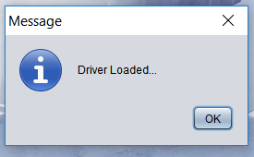

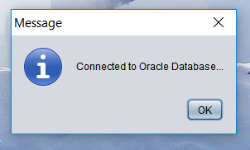

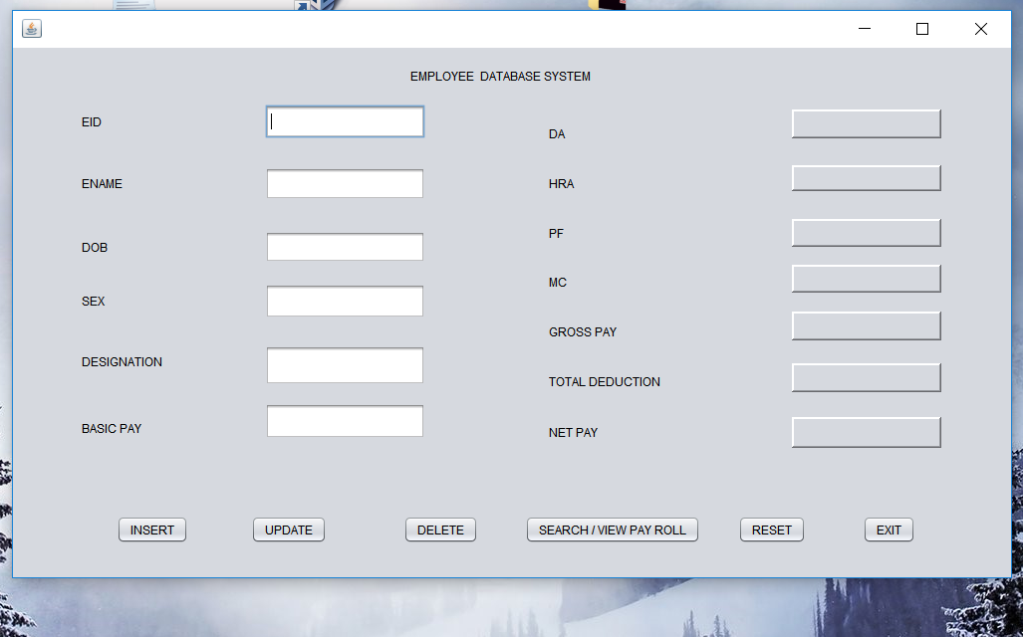

**INSERTING IN APPLICATION:**

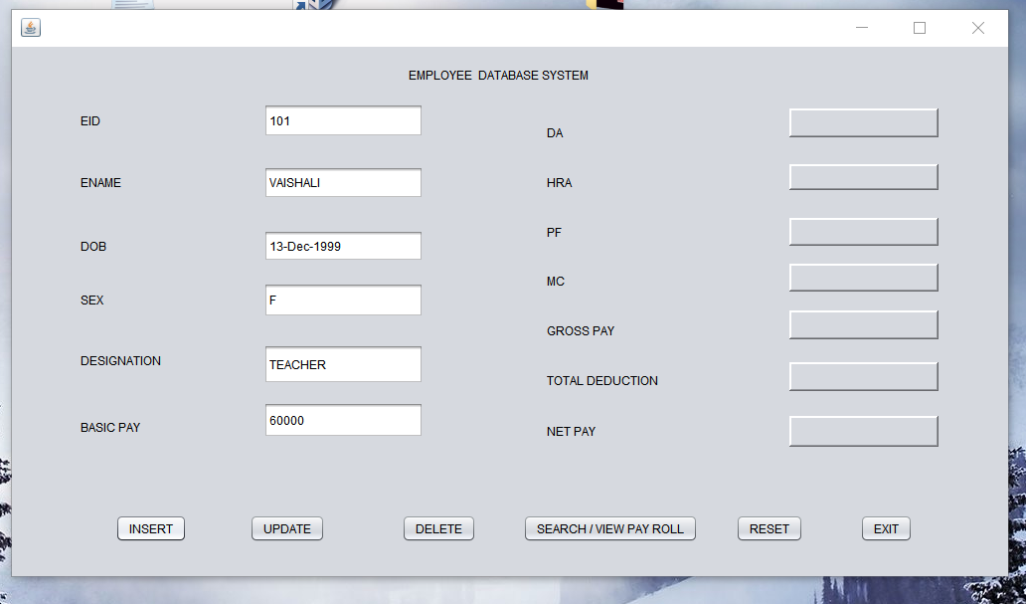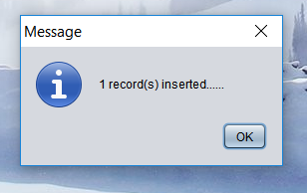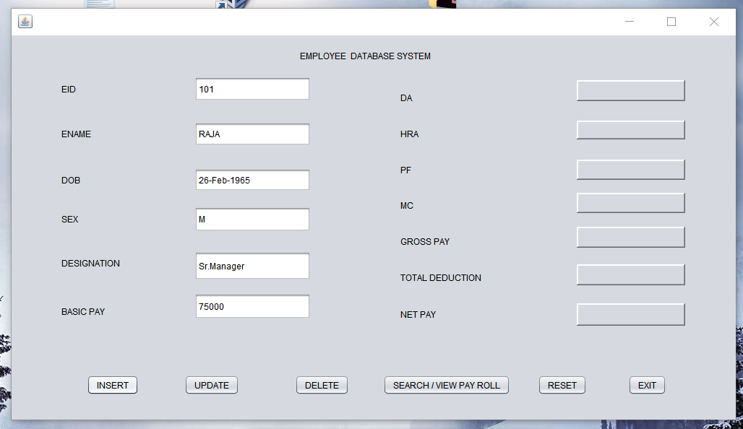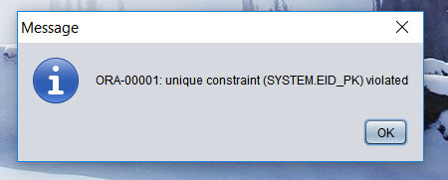

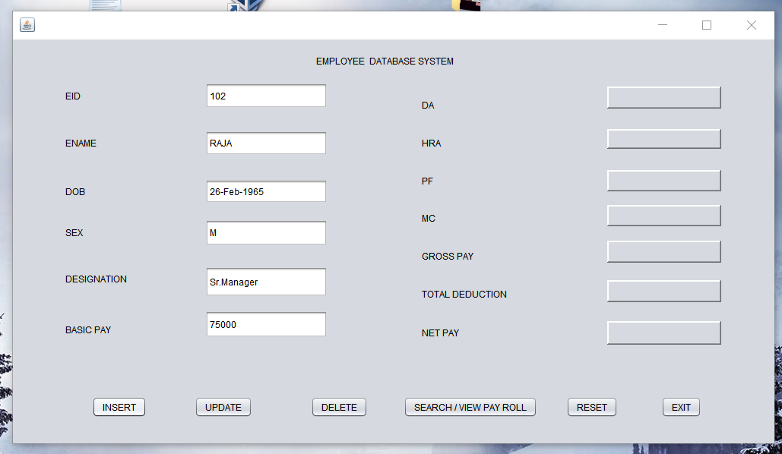



**SEARCH/VIEW PAYROLL:**

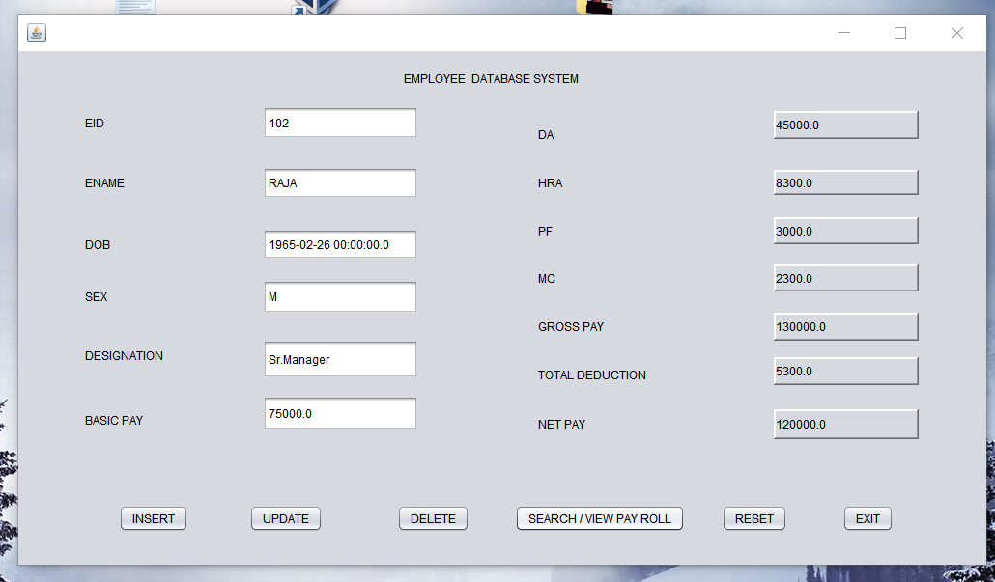

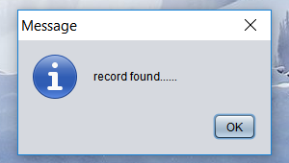

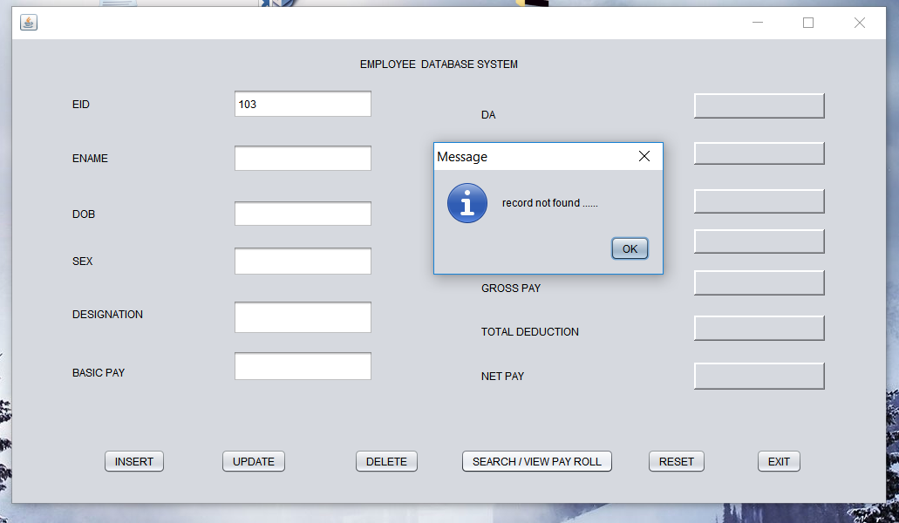

**UPDATING IN APPLICATION:**

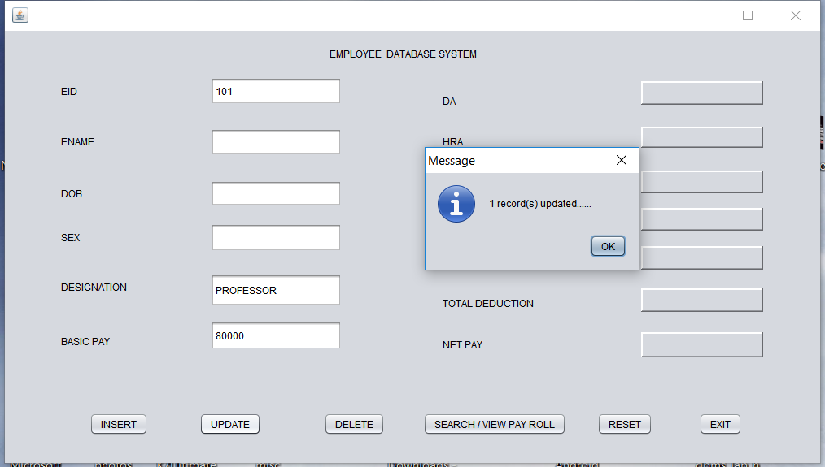

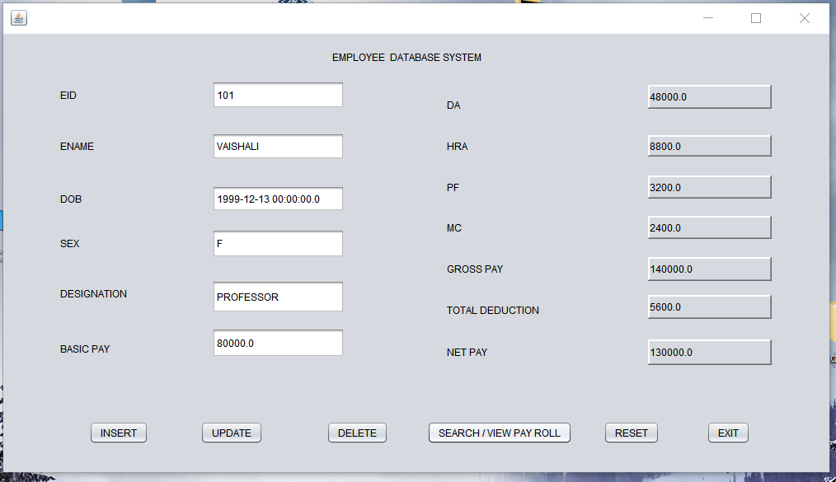

**DELETING IN APPLICATION:**

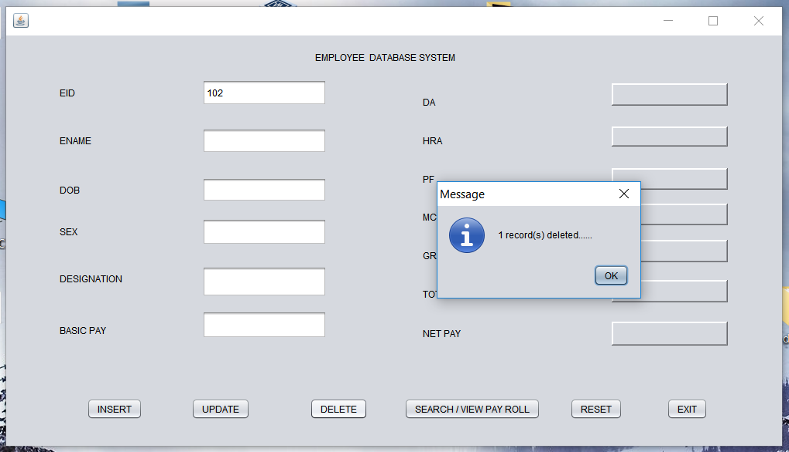

**INSERTING IN DATABASE:**

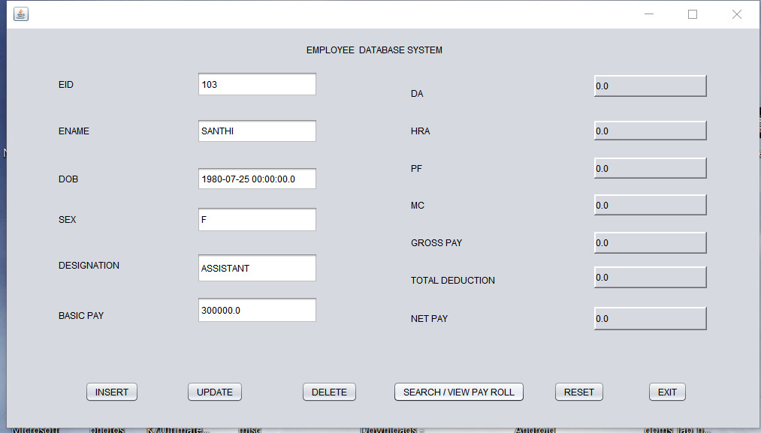

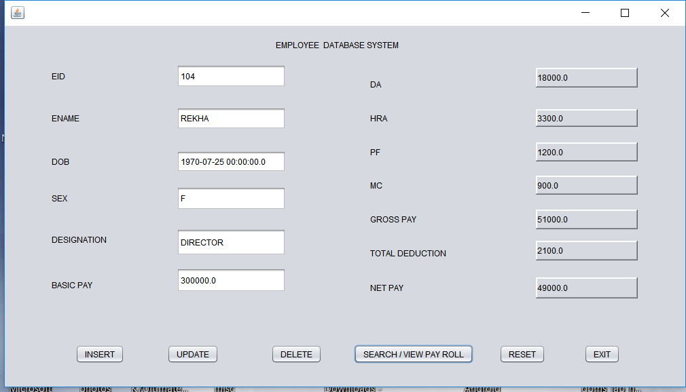

**UPDATE IN DATABASE:**

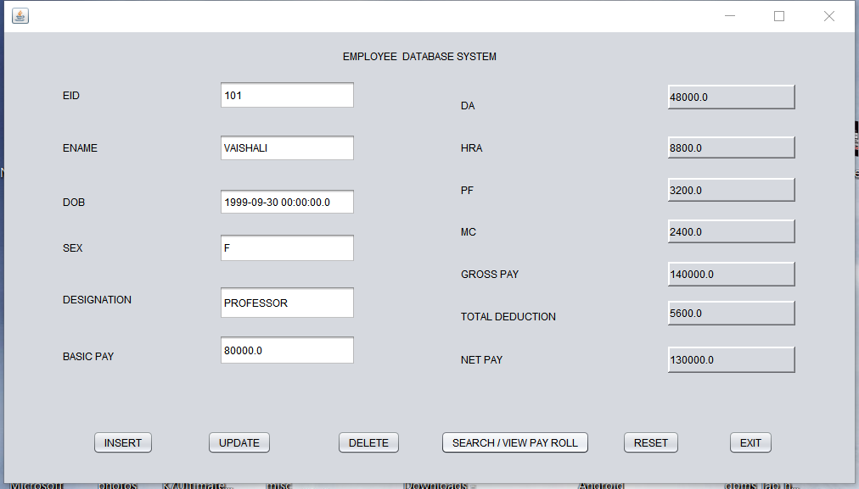

**DELETING IN DATABASE:**

